**Name:** Shivam Verma

**Course:** B.Sc. (H) Computer Science

**Semester:** 5th

**College Roll No.:** 19HCS4048

**Subject:** Data Analysis and Visualization

Q8. Consider the following data frame containing a family name, gender of the family member and her/his monthly income in each record.

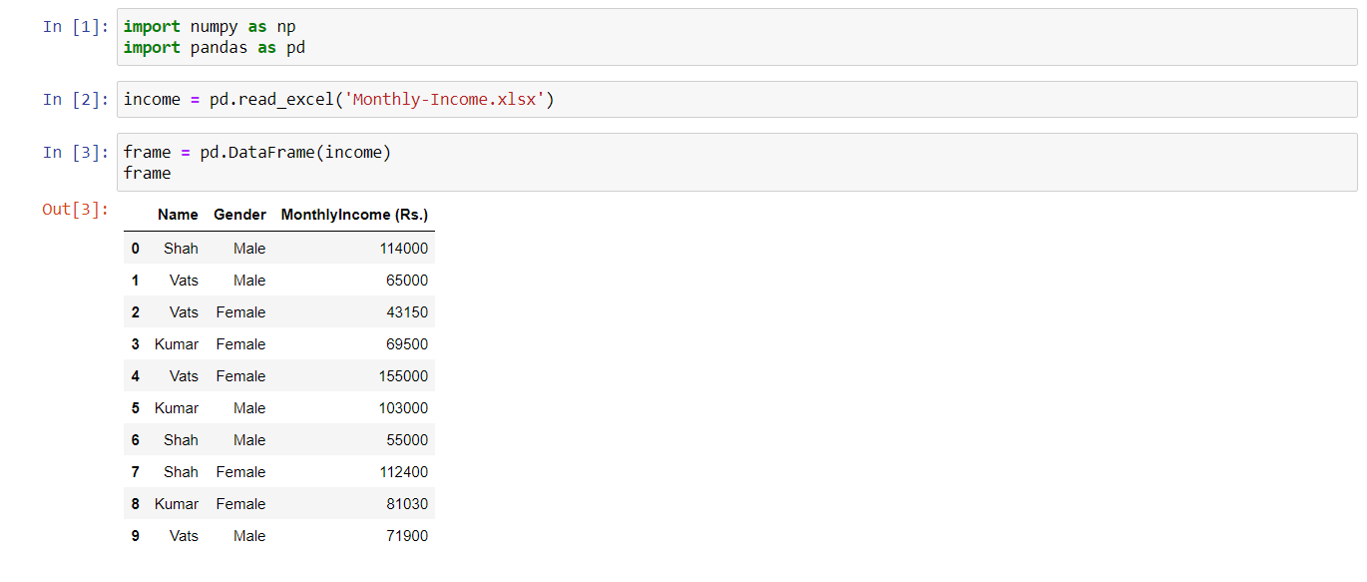

Write a program in Python using Pandas to perform the following:

1. Calculate and display familywise gross monthly income.

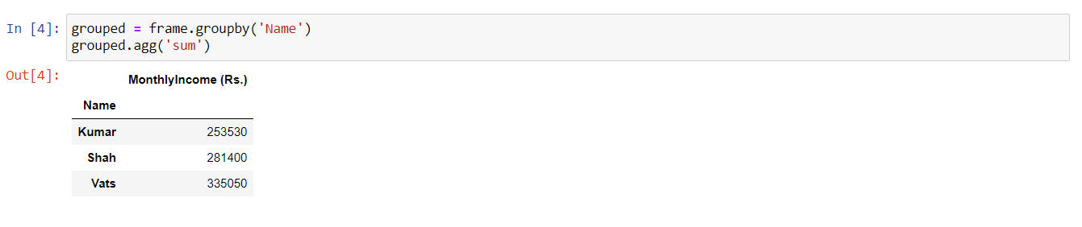

1. Calculate and display the member with the highest monthly income in a family.

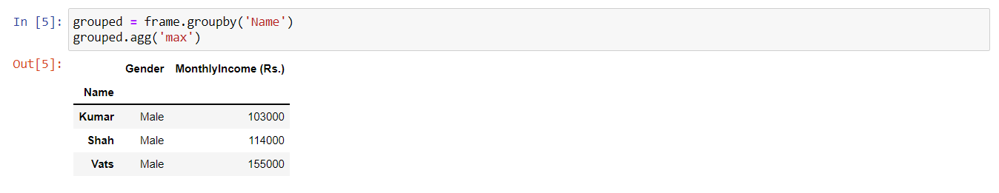

1. Calculate and display monthly income of all members with income greater than Rs. 60000.00.

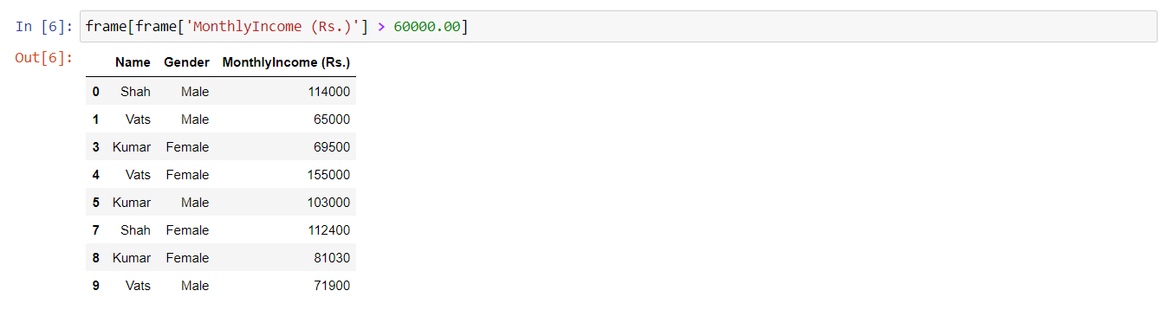

1. Calculate and display the average monthly income of the female members in the Shah family.

